| **Learning Unit:** Starter | | **Group Size:** 30 | **Class:** English 1B | |
| --- | --- | --- | --- | --- |
| **Topic:** Reviewing what we know | | | **Time:** 60 minutes | |
| **Skill Focus:** writing skill, reading skill, listening skill, speaking Skills | | | | |
| **Lesson Objectives:** By the end of the lesson the;   * Students will be able to understand subject pronouns * Students will be able to write numbers * Students will be able to understand demonstrative pronouns | | | | |
| **Materials:** Book and PowerPoint presentation | | | | |
| **Step** | **Interaction** | **Teaching-Learning Activities Strategies** | | **Time** |
| **E**  **N**  **G**  **A**  **G**  **E** | Teacher and students | * **Question:** What can we remember about numbers and letters? Focusing on spelling and fluency. | | 10 mins |
| **S**  **T**  **U**  **D**  **Y** | Teacher and students  Open to page 6 in the student book | **Vocabulary**   * alphabet and numbers   **Spelling:**  We are focusing on spelling. Making sure students know how to spell each number. | | 20 mins |
| **A**  **C**  **T**  **I**  **V**  **A**  **T**  **E** | Teacher   * This requires very little preparation, and is similar to the multiplication version for mathematics. * This allows me to see where the students are in their listening, fluency, and understanding abilities. | Students   * We are going to play “around the world” this is a memorization style of game. * The students will each stand at their desk and have to go in order saying the next letter in the alphabet. Each time a student is incorrect or takes more than five seconds they have to sit down. * The next student must give the person their correct answer or they must also sit down. * This continues until we get through the entire alphabet. The people standing are the winners. * We continue by going through the numbers to 100 as well. | | 15  mins |
| **C**  **L**  **O**  **S**  **U**  **R**  **E** | Students and Teacher | **Homework**  Workbook page 5. | | 5 mins |

| **Learning Unit:** 1 | | **Group Size:** 30 | **Class:** 1B | |
| --- | --- | --- | --- | --- |
| **Topic:** School Life | | | **Time:** 60 minutes | |
| **Skill Focus:** Writing skill, Reading skill, Listening skill, Speaking Skills, Grammar skills | | | | |
| **Lesson Objectives:** By the end of the lesson the students will:   * Know classroom objects * Understand articles * Understand when to use plural nouns * Match descriptions with pictures * Listen for details | | | | |
| **Materials:** Book | | | | |
| **Step** | **Interaction** | **Teaching-Learning Activities Strategies** | | **Time** |
| **E**  **N**  **G**  **A**  **G**  **E** | Teacher and students | * **Question:** What can we find in our classroom. * I will project a blank piece of paper we will fill with furniture and items we notice in the classroom checking to see how many things we can find. | | 10 mins |
| **S**  **T**  **U**  **D**  **Y** | Teacher and students | * We will work on page 9, 10, and 11 in our workbook. * The pages go over classroom vocabulary items. * The pages go over reading comprehension. * The pages have speaking sections. * The pages have article grammar lessons. | | 15 mins |
| **A**  **C**  **T**  **I**  **V**  **A**  **T**  **E** | Teacher and Students | **Speaking in class**   * There is a reading section on page 10 for us to work on. * The wheel of names will select three students to read the paragraph about what each student has in their backpack. * The wheel will then pick students who will answer the question about each person. | | 15 mins |
| **C**  **L**  **O**  **S**  **U**  **R**  **E** | Students and Teacher | **Homework:**   * We will work in class on workbook page 6, 7, 8. | | 10 mins |

| **Learning Unit:** 2 | | **Group Size:** 30 | **Class:** 1B | |
| --- | --- | --- | --- | --- |
| **Topic:** Friends and Family | | | **Time:** 60 minutes | |
| **Skill Focus:** Writing skill, Reading skill, Listening skill, Speaking Skills | | | | |
| **Lesson Objectives:** By the end of the lesson the;   * Students will understand family relationships * Students will know possessive adjectives * Students will know Possessive ‘s * Students will be able to scan a text | | | | |
| **Materials:** Book and PowerPoint presentation, YouTube | | | | |
| **Step** | **Interaction** | **Teaching-Learning Activities Strategies** | | **Time** |
| **E**  **N**  **G**  **A**  **G**  **E** | Teacher and students | * Tell students how many people are in your family, e.g. In my family, there are four people. * Ask: How many people are there in your family? Who are they? Elicit answers from one or two individual students. * Ask more questions using vocabulary that students learned in the Starter Unit, e.g. * What are your parents’ names? * How many girls/boys are there in your family? * Put students into pairs to tell each other about their families. * Are there any pets in your family? What are their names? Elicit a few answers from individual students | | 15 mins |
| **S**  **T**  **U**  **D**  **Y** | Teacher and students | * Students learn nouns for 14 family members and pets. They identify these by matching them to pictures on a family tree, then confirm understanding by categorising them into a table. They personalise the vocabulary by asking and answering questions about their own family tree. * We are working on page 19 in our student books. | | 15 mins |
| **A**  **C**  **T**  **I**  **V**  **A**  **T**  **E** | Students | The students will watch the included vlog we have with our textbook.   * This lesson features a vlog in which a vlogger talks about choosing a new pet. You can watch this in class if you have time and access to a computer or tablet, or you can ask sts to download it from the Richmond Learning Platform to watch at home. See TG pages 267 and 284 | | 10 mins |

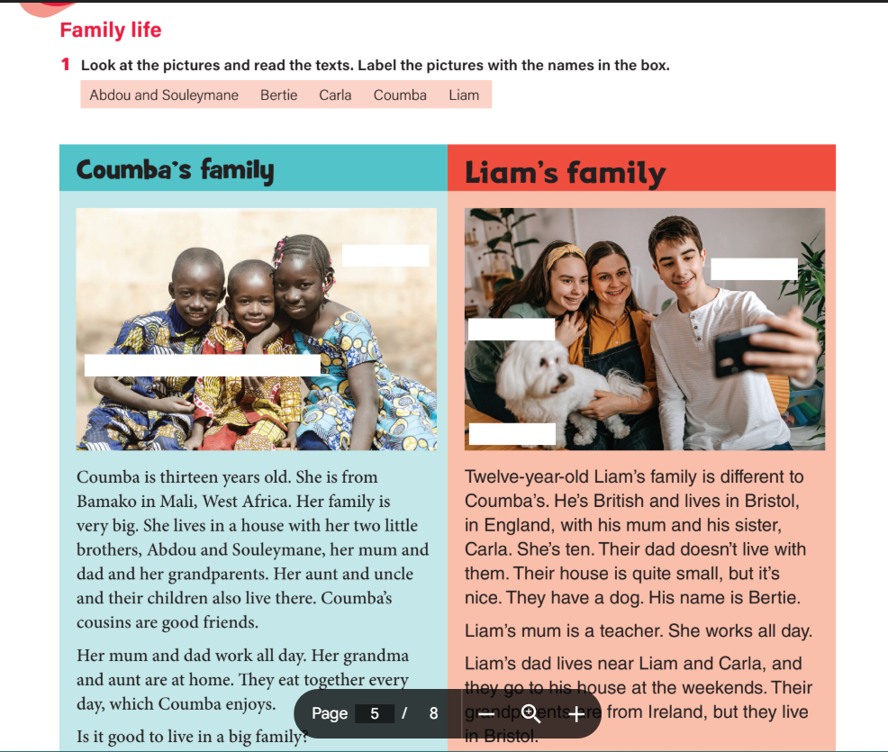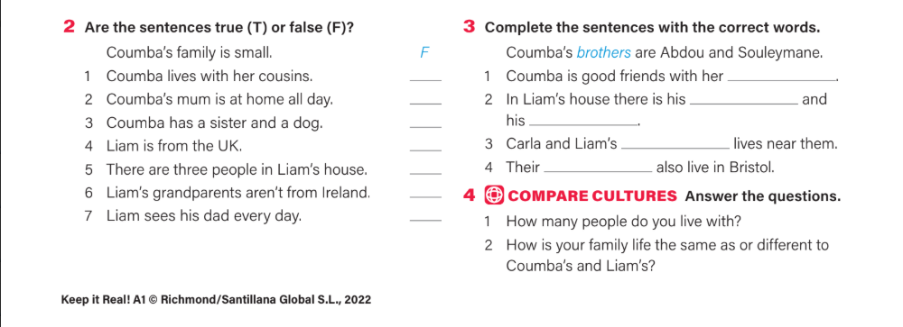

| **Learning Unit:** 3 | | **Group Size:** 30 | **Class:** 1B | |
| --- | --- | --- | --- | --- |
| **Topic:**At Home | | | **Time:** 60 minutes | |
| **Skill Focus:** Writing skill, Reading skill, Listening skill, Speaking Skills | | | | |
| **Lesson Objectives:** By the end of the lesson the;   * Students will know home object vocabulary * There is/there are * Prepositions of place * Use pictures to help understand a text * Identify location of objects | | | | |
| **Materials:** Book and PowerPoint presentation, | | | | |
| **Step** | **Interaction** | **Teaching-Learning Activities Strategies** | | **Time** |
| **E**  **N**  **G**  **A**  **G**  **E** | Teacher and students | * We are going to go over what we remember about plural and singular nouns. | | 10 mins |
| **S**  **T**  **U**  **D**  **Y** | Teacher and students | **Introduction**   * Start the lesson by explaining the difference between There is/there on the board   **There is/There are**   * Teach students how to form sentences using There is/There are * Provide examples and have students list down sentences using There is/There are their notebooks.   **Talk about negative form and questions**   * Go back to our rule box and see when each is used and how. * Demonstrate how to form sentences using There isn’t/ there aren’t. * Have students practice forming sentences using all five types. | | 20 mins |
| **A**  **C**  **T**  **I**  **V**  **A**  **T**  **E** | Students | * We will play hotseat (look at the provided video below) * Students will try to form sentences using there is/ there are with the unit vocabulary.   [How To Play Hot Seat | Fun Classroom Game](https://www.youtube.com/watch?v=Ei0OtZsB2UQ) | | 10 mins |
| **C**  **L**  **O**  **S**  **U**  **R**  **E** | Students and Teacher | Review the lesson by asking students to summarize. | | 10 mins |

| **Learning Unit:** Review Unit 4 | | **Group Size:** 30 | **Class:** 1B | |
| --- | --- | --- | --- | --- |
| **Topic:** Food and Drink | | | **Time:** 60 minutes | |
| **Skill Focus:** Team work, Grammar, Spelling, Vocabulary comprehension | | | | |
| **Lesson Objectives:** By the end of the lesson the;   * Students will be able to spell vocabulary words. * Students will be able to find the odd word in a sequence and remove it. * students will be able decide which sentences are formed correctly with like/don’t like. * Students will be able to tell when to use would like. * Students will be able to “transfer information into a table”. * Students will be prepared for their Unit 4 Exam. | | | | |
| **Materials:** Book and PowerPoint presentation, | | | | |
| **Step** | **Interaction** | **Teaching-Learning Activities Strategies** | | **Time** |
| **E**  **N**  **G**  **A**  **G**  **E** | Teacher and students | **We will discuss class business:**   * When we will be completing our revisions. * When we will be correcting the revisions and studying together. * When our exam will take place. * Last I will tell them we have a Kahoot to play today! (They will be extremely excited) | | 10 mins |
| **S**  **T**  **U**  **D**  **Y** | Teacher and students | **preparation**   * Students should be very familiar with the information at this point, but I will briefly go over what kind of questions they might see on the Kahoot and what they will see on the revision and exam. | | 10 mins |
| **A**  **C**  **T**  **I**  **V**  **A**  **T**  **E** | Students | Students will pick a team of two and join the Kahoot on their phones.  Each question will give the results of how many students missed the question which they had selected instead so I will explain every answer depending on why they missed it.  The questions will be like the revision and exam but not the same. I will be able to see where our strong and weak points are on average and add more focus to it before we take the exam. | | 20 mins |
| **C**  **L**  **O**  **S**  **U**  **R**  **E** | Students and Teacher | **Homework**:  I will ask the students to complete the workbook revision for unit 4. | | 10 mins |